MODULE 2 EXERCISE
Use the following decision tree to guide your choice of survey method. Then answer the questions at the bottom to reflect on your choice and think through its rationale and resource implications. Finally, review the cheat sheet on the next page to make sure you made the best choice!
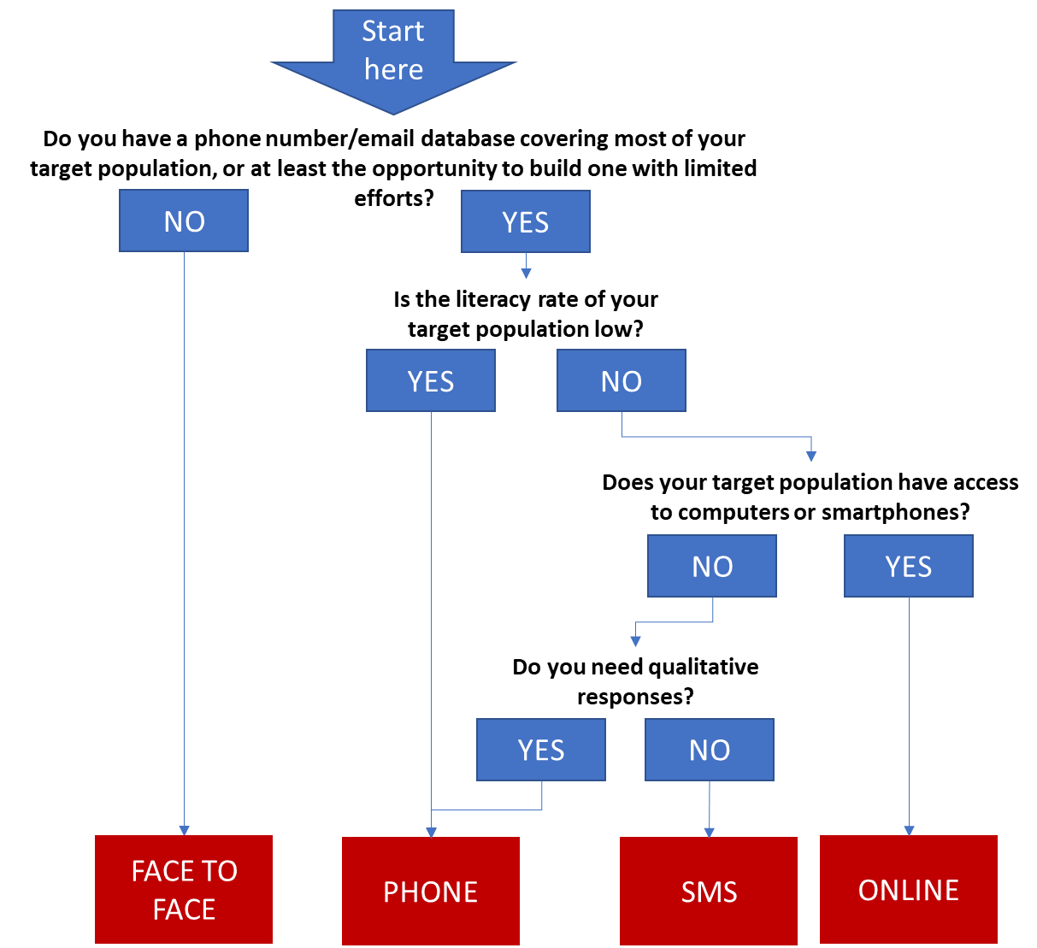

Questions:
  - Which survey method did you choose? Click or tap here to enter text.
  - Why did you choose this method? Click or tap here to enter text.
  - What are the main concerns you have about this method? Click or tap here to enter text.
  - Describe the resources you will need to run a survey with your selected method, in terms of staff and tools to run the survey: Click or tap here to enter text.
  - Will you need to spend any actual cash (e.g. sending SMS or buying services)? If yes, how much? Do you have this budget available? Click or tap here to enter text.

M2 Checklist

Online is the right choice if:
☐ Your target population has regular access to internet, either through a smartphone or a computer
☐ You have a way to make sure the respondents are actually the people meant to respond (e.g. you can target them via personal emails)
☐ You have a large target population and an extensive list of email addresses, to make up for the likely relatively low participation rates.

Phone is the right choice if:
☐ You have a reliable database of phone numbers through which you can reach the people meant to respond
☐ You can dedicate resources to conduct the required phone interviews within a limited time span (e.g. 2 weeks)
☐ You are able to conduct the phone interviews during a time of day that your respondents are likely to be available.

SMS is the right choice if:
☐ You have few questions (<10-12) and they are mostly close-ended
☐ Your target population is literate, has access to mobile phones and is comfortable with writing SMS in a survey mode
☐ Your target population is familiar with your products or services already and is possibly used to you contacting them directly
☐ Your respondents have a strong interest in answering your SMS: given that they will have to spend time and possibly money answering your questions
☐ You have a large target population and an extensive list of email addresses, to make up for the likely relatively low participation rates.

Face-to-face is the right choice if:
☐ You do not have another reliable way to reach your respondents
☐ You can fit the survey into in-person interactions that would occur anyway as part of your normal operations (e.g. customers coming to your place of business, community meetings, etc.)
☐ You have a way to ensure a representative sample among the pool of respondents that you would end up interviewing.

